EARLIEST-DEADLINE FIRST
#include <stdio.h>

struct Process {
int id, at, bt, deadline, remaining;
};

int main() {
int n, i, t = 0, completed = 0;

scanf("%d", &n);

struct Process p[n];

for (i = 0; i < n; i++) {
scanf("%d %d %d", &p[i].at, &p[i].bt, &p[i].deadline);
p[i].id = i + 1;
p[i].remaining = p[i].bt;
}

float U = 0;
for (i = 0; i < n; i++)
U += (float)p[i].bt / p[i].deadline;

if (U > 1)
printf("Not Feasible\n");
else
printf("Feasible\n");

int gantt[100];

while (completed < n) {
int idx = -1, min_deadline = 9999;

for (i = 0; i < n; i++) {
if (p[i].at <= t && p[i].remaining > 0) {
if (p[i].deadline < min_deadline) {
min_deadline = p[i].deadline;
idx = i;
}
}
}

if (idx != -1) {
gantt[t] = p[idx].id;
p[idx].remaining--;
if (p[idx].remaining == 0)
completed++;
} else {
gantt[t] = 0;
}

t++;
}

printf("\n+");
for (i = 0; i < t; i++)
printf("-----+");

printf("\n|");
for (i = 0; i < t; i++) {
if (gantt[i] == 0)
printf("Idle |");
else
printf(" P%-2d |", gantt[i]);
}

printf("\n+");
for (i = 0; i < t; i++)
printf("-----+");

printf("\n0");
for (i = 1; i <= t; i++)
printf(" %d", i);

return 0;
}

OUTPUT:
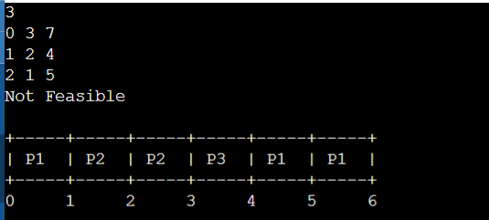

Observation book:
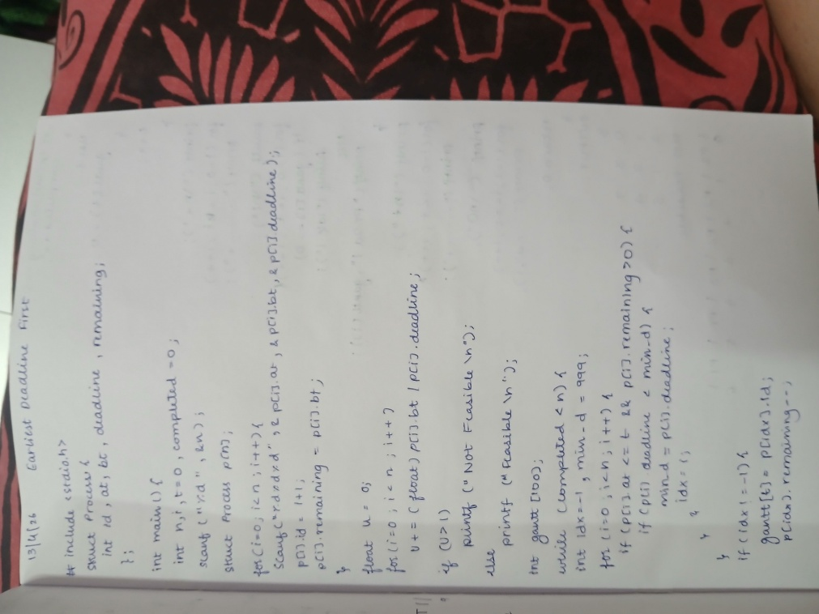
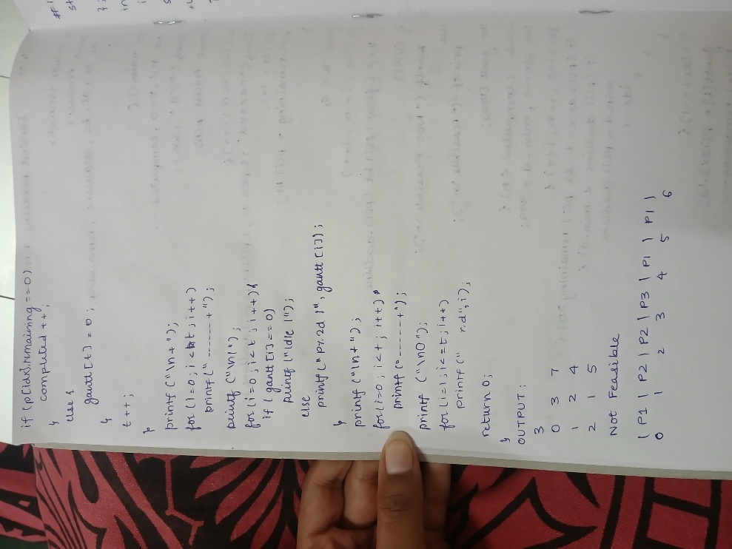

PROPORTIONAL SHARE SCHEDULING
#include <stdio.h>

struct Process {
int id, at, bt, weight, remaining;
};

int main() {
int n, i, t = 0, completed = 0, tq;

scanf("%d", &n);

struct Process p[n];

for (i = 0; i < n; i++) {
scanf("%d %d %d", &p[i].at, &p[i].bt, &p[i].weight);
p[i].id = i + 1;
p[i].remaining = p[i].bt;
}

scanf("%d", &tq);

int total_weight = 0;
for (i = 0; i < n; i++)
total_weight += p[i].weight;

int gantt[200], g = 0;

while (completed < n) {
for (i = 0; i < n; i++) {
if (p[i].remaining > 0 && p[i].at <= t) {

int slice = (p[i].weight * tq) / total_weight;
if (slice <= 0) slice = 1;

int k;
for (k = 0; k < slice && p[i].remaining > 0; k++) {
gantt[g++] = p[i].id;
p[i].remaining--;
t++;
}

if (p[i].remaining <= 0) {
completed++;
total_weight -= p[i].weight;
}
}
}
}

printf("\n+");
for (i = 0; i < g; i++)
printf("-----+");

printf("\n|");
for (i = 0; i < g; i++)
printf(" P%-2d |", gantt[i]);

printf("\n+");
for (i = 0; i < g; i++)
printf("-----+");

printf("\n0");
for (i = 1; i <= g; i++)
printf(" %d", i);

return 0;
}
OUTPUT:
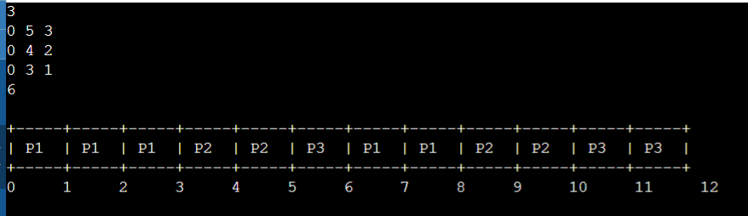

Observation book:
